Written Report

In order to minimize costs, the optimal measurements of carpet cuts would be:

* 40 rolls of 14 foot width, each roll cut into one 9 foot width section and one 4 foot width section.
* 90 rolls of 14 foot width, each roll cut into one 12 foot width section.
* 80 rolls of 18 foot width, each roll cut into two 9 foot width sections.

With this group, you would have a minimum cost of $242,000 and meet the demand requirements.

Appendices

1. Lindo input for carpet cutting problem

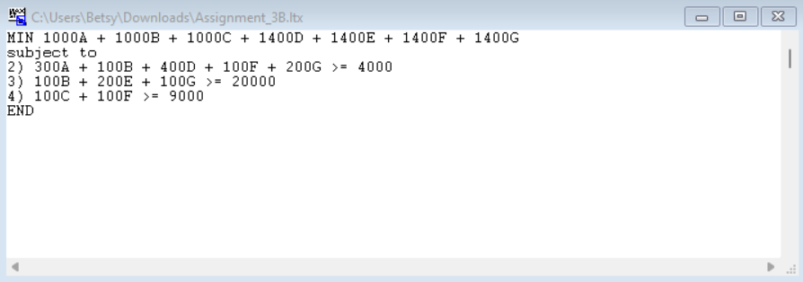

1. Lindo output for carpet cutting problem

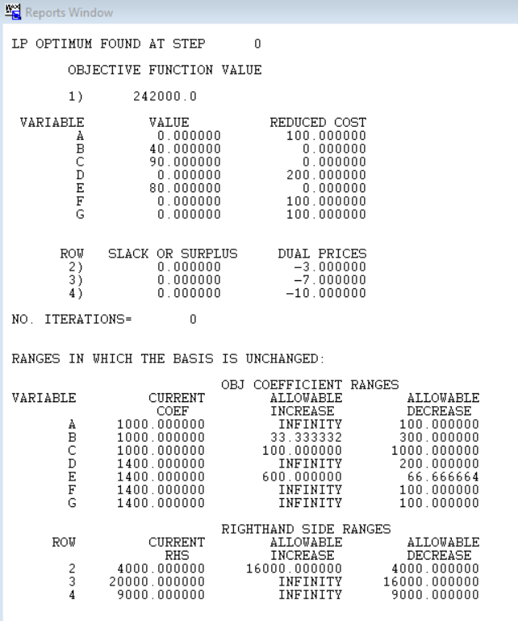

1. Constraints testing

| Constraint | Proof of constraint being followed |
| --- | --- |
| 300A + 100B + 400D + 100F + 200G >= 4000 | 0 + 100(40) + 0 + 0 + 0 >= 4000  4000 >= 4000 |
| 100B + 200E + 100G >= 20000 | 100(40) + 200(80) + 0 >= 20000  20000 >= 20000 |
| 100C + 100F >= 9000 | 100(90) + 0 >= 9000  9000 >= 9000 |